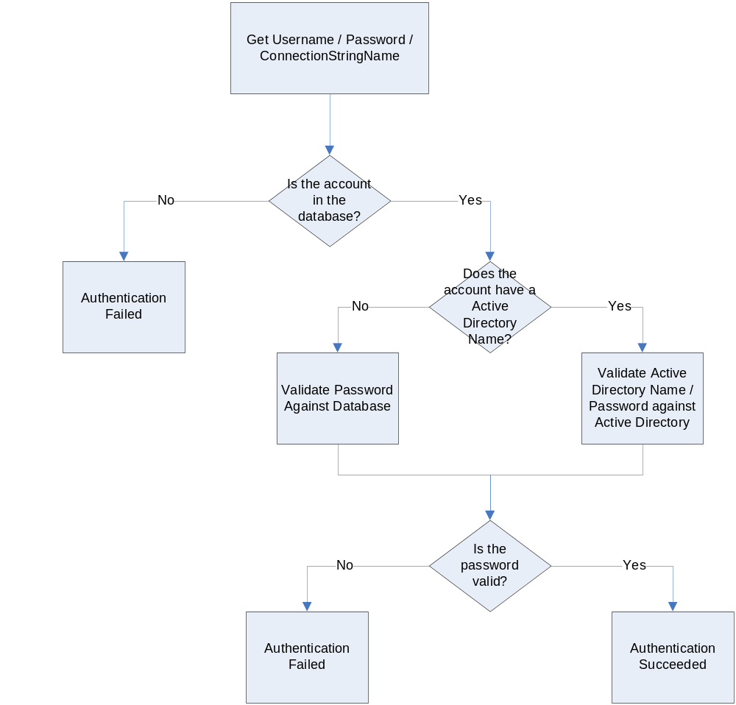
Pros | Cons
User has to re-authenticate to access the application, but shares the password used for windows login. | User has to re-authenticate to access the application.
The application has full control over the authentication of a user. This allows you to take advantage of the built-in forms authentication for web instead of having to write your own.
Allows for mixing types of authentication, integrated and application for environments that have generic logins for windows (operator logins).
Unifies Windows and Web Authentication to appear the same to the user.
Allows Authentication from computers not joined to the domain.

